Mastering @ConditionalOnProperty
This is one of the most powerful but misunderstood annotations in Spring Boot.
It decides which Beans even exist in your application.

Why does this concept exist?
In real projects:
• Hundreds of Beans exist
• Not all are needed always
• Some are environment-specific
• Some are feature-specific
Without conditions:
→ All Beans load
→ Startup slows
→ Memory increases
→ Conflicts occur
We need conditional bean creation.

Why @ConditionalOnProperty Exists ?
Problem:
Spring by default eagerly creates Beans.
Result:
IoC Container becomes cluttered.
Example:
You support both:
• MySQL
• NoSQL
Without conditions → both connections load.

This creates:
• Conflicts
• Wasted resources
• Wrong runtime behavior

What is @ConditionalOnProperty ?
It is a Spring Boot conditional annotation.
It tells Spring:
“Create this Bean only if a property matches a value.”
It links:
application.properties → Bean existence

Where It Fits in Spring Boot Architecture ?
Flow:
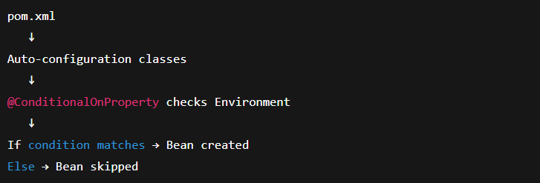This happens during ApplicationContext startup.

Real-World Use Case
Scenario
Company migrating from MySQL → NoSQL
We want:
• Only one DB connection active
• Switchable via config

Base Setup (Without Condition — Problem)
Interface
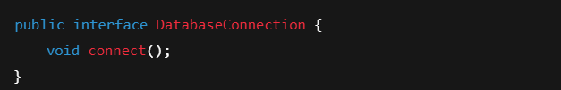MySQL
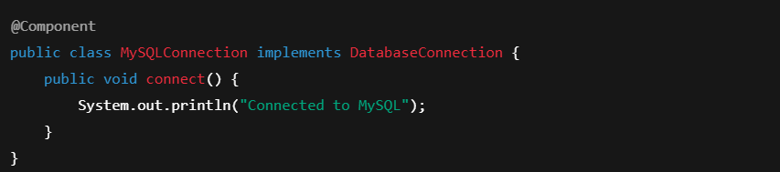
NoSQL
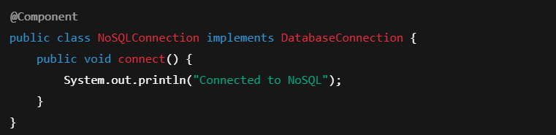Injection
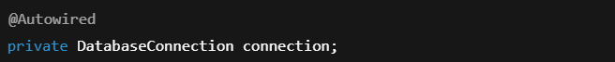

❌ Result:
No qualifying bean of type DatabaseConnection
2 beans found: MySQLConnection, NoSQLConnection

Applying @ConditionalOnProperty
MySQL Bean
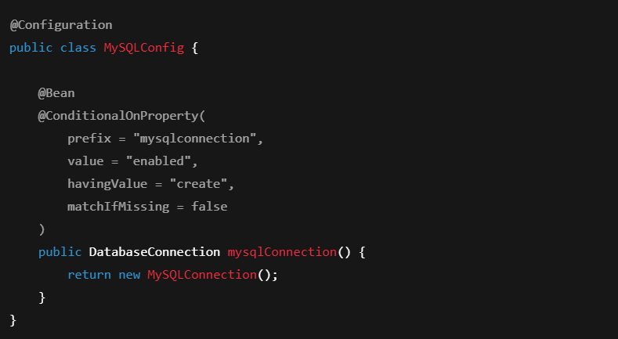
NoSQL Bean
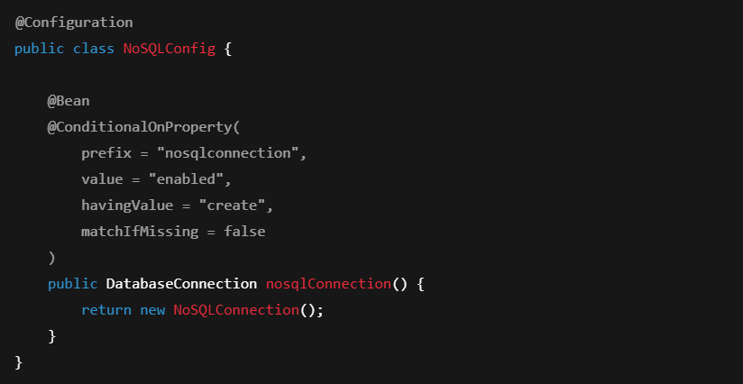

application.properties Cases
Case 1
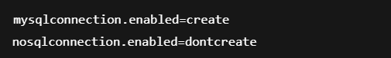
Result:
✔ MySQL Bean created
❌ NoSQL Bean skipped

Case 2
Result:
✔ NoSQL Bean created
❌ MySQL Bean skipped

Case 3 — No Property In Application Properties + matchIfMissing = true
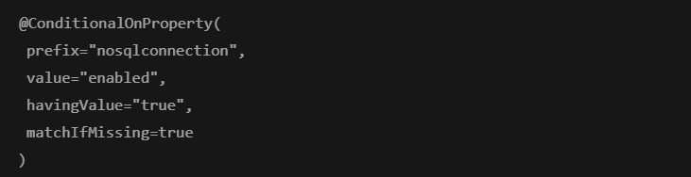Result:
✔ Bean created by default

Case 4 — No Property In Application Properties + matchIfMissing = false
Result:
❌ Bean NOT created

Why @Autowired(required = false) Is Needed
Without this:
If no Bean is created → App crashes.
With this:
Application starts safely with bean as null if not created.

Combined Case: Two Conditional Beans
mysql.enabled | nosql.enabled | Result
create | dontcreate | MySQL
dontcreate | create | NoSQL
dontcreate | dontcreate | No Bean
create | create | Conflict

How Spring Executes This Internally
Startup Flow:
- SpringApplication.run()
- Loads Environment (properties)
- Loads auto-config classes
- Sees @ConditionalOnProperty
- Reads Environment
- Matches values
- Registers Bean or skips
This happens before Beans exist.

Advantages
• Feature toggling
• Faster startup
• Cleaner IoC container
• Environment-based behavior

Disadvantages
• Misconfiguration risk
• Debug complexity
• Harder local testing

Differences Table
Annotation | Purpose
@Profile | Environment based
@ConditionalOnProperty | Config based
@ConditionalOnClass | Classpath based

Hidden Traps
• Property typo = Bean missing
• Both Beans ON = startup failure
• Proxy injection confusion
• Silent behavior changes

Interview Perspective
They test:
✔ Do you understand config-driven architecture
✔ Do you know startup internals
✔ Can you design flexible systems

Most Asked Interview Questions
- What is @ConditionalOnProperty?
→ Property-based Bean creation control.
- When is it evaluated?
→ During context startup.
- Difference from @Profile?
→ Property vs Environment based.
- What is matchIfMissing?
→ Default behavior if property absent.
- Why use required=false?
→ Prevent startup failure.
- Can it be used on classes?
→ Yes.
- What happens if both Beans match?
→ Conflict exception.
- Is this Spring or Spring Boot?
→ Spring Boot only.
- Where is logic implemented?
→ spring-boot-autoconfigure jar.
- Can it override auto-config beans?
→ Yes.

One-Page Mental Model
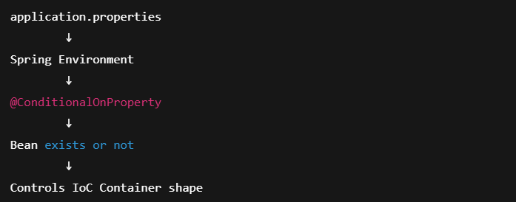

Enterprise Relevance
Used heavily in:
• Microservices
• Feature flags
• Multi-DB systems
• Cloud-native apps

Summary as a Story
- You create a Spring Boot app.
- You add MySQL & NoSQL dependencies.
- Spring Boot starts.
- It loads application.properties.
- Environment is built.
- Before creating Beans, Spring reads:
- Spring sees: “MySQL Bean condition matched.”
- It registers MySQLConnection.
- It skips NoSQLConnection.
- IoC Container is shaped by configuration.
Your app behavior changed — without touching code.
That is configuration-driven architecture.

In real systems, this is how:
• Features are toggled
• Databases are switched
• Integrations are enabled/disabled
• Environments behave differently
This is configuration-driven architecture.

Core Definitions
Term | Meaning
Bean | Object managed by Spring
IoC Container | ApplicationContext
Environment | All properties loaded
@Configuration | Class that defines Beans
@Bean | Method that creates a Bean
@ConditionalOnProperty | Property-based Bean filter

